

|  |
| --- |
| Introduction |

**Overview**

A business proposal is a written offer from a seller to a prospective client or investor. Business proposals are often a critical step in the complex sales process. A proposal ultimately tells the buyer about the seller's capabilities to satisfy their needs.



*A photo of the team*

Most business proposals begin with a background of the brand or company. You can include your logo, a few photos, a brief explanation of your goals, and even a short anecdote about your beginnings. Make sure everything is clear to your potential customers. The bulk of your proposal should include things like a list of services, logistics, and pricing. Add examples for a clearer picture, and include graphs and charts if you need to present data. It also helps to have testimonials from former clients, giving readers a better look at your brand.

**Leadership**

|  |  |  |
| --- | --- | --- |
| **Name** | **Role** | **Description** |
| Cassandra Lopez | *Chief Executive Officer* | Explain what they do for the business. How much experience do they have? What are their achievements? You may also add a fun fact about them. |
| Name a C-level executive | *Provide their title* |  |
| Name a C-level executive | *Provide their title* |  |
| Name a C-level executive | *Provide their title* |  |

|  |
| --- |
| Industry Analysis |

**SWOT Analysis**

**Name of Competitor 1: *Pin & Ark***

|  |  |  |  |
| --- | --- | --- | --- |
| **Strengths** | **Weaknesses** | **Opportunities** | **Threats** |
| Enumerate internal features that the company does well | Enumerate internal features that need to be improved | Name external factors that benefit the company | Name external factors that work against the company |
|  |  |  |  |
|  |  |  |  |
|  |  |  |  |

**Name of Competitor 2**

|  |  |  |  |
| --- | --- | --- | --- |
| **Strengths** | **Weaknesses** | **Opportunities** | **Threats** |
| Enumerate internal features that the company does well | Enumerate internal features that need to be improved | Name external factors that benefit the company | Name external factors that work against the company |
|  |  |  |  |
|  |  |  |  |
|  |  |  |  |

**Industry Analysis**

Provide an analysis of the broader industry. Zoom in on your business sector - its location, size, and available products and services.

Who are the usual players in the industry? Is there a major entity that dominates the market? Which companies are your key competitors based on the data?

Finally, explain what makes your business stand out. What edge do you have over these competitors? Anticipate how competitors will respond to the arrival of your business, and explain how you will address these challenges.

**Data Analysis**

Visualize complicated and dense information with graphs and charts. These visual aids add more context to the topic you are discussing.

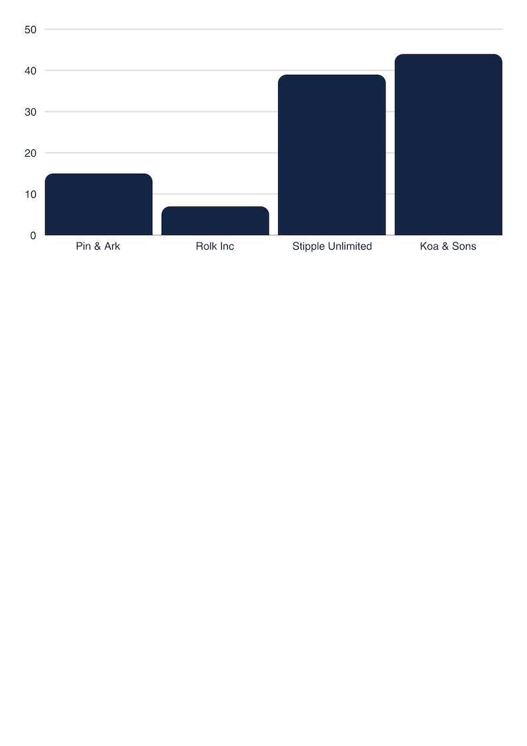

***Market share of major players in the industry***

|  |
| --- |
| Budget Plan |

**Proposed Budget**

In this section, describe how you plan to use resources.

|  |  |
| --- | --- |
| **Project** | **Amount** |
| Phase 1 | $456,000 |
| Phase 2 | $421,000 |
| Phase 3 | $123,000 |
| **TOTAL** | **$1,000,000** |

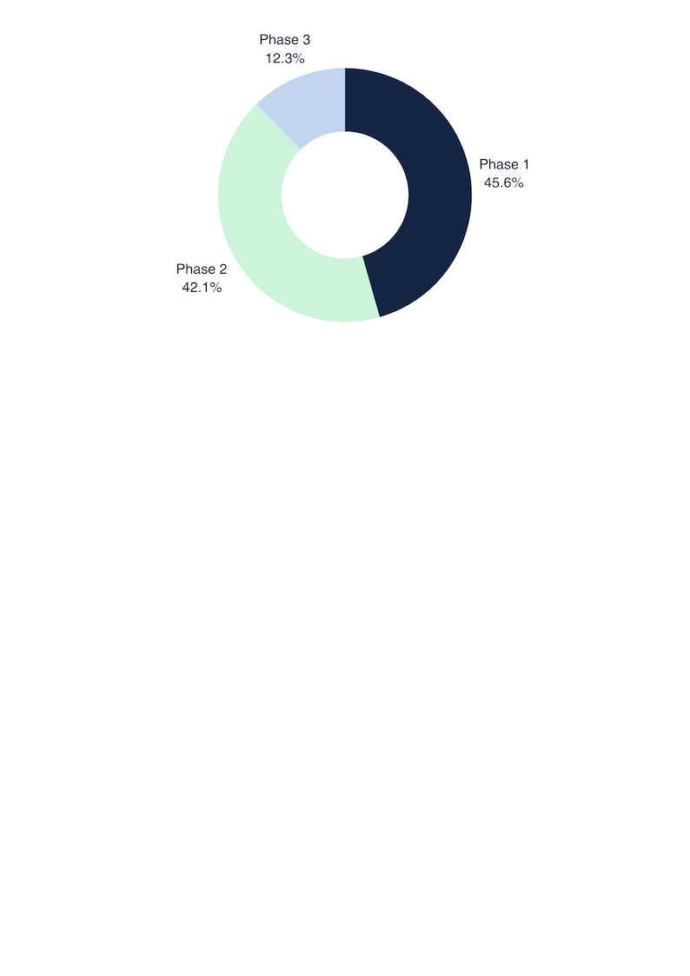

**Financial Outlook**

If your client is an investor, you may also provide a projection of the business's financial performance within a specific time frame. Investors will want to know when they will receive a return on their investment.

|  |  |  |  |
| --- | --- | --- | --- |
| **US$ B** | **FY'31** | **FY'30** | **YOY change** |
| Revenue | 789.00 | 456.00 | 73% |
| Expenses | 246.00 | 300.00 | -18% |
| Profit | 543.00 | 156.00 | 248% |

|  |
| --- |
| Roadmap and Milestones |

Map out your future plans for the business, which could include expansion projects, new product offerings, and major partnerships. Discuss how much impact you want to bring to the industry. This enables potential investors also to be optimistic about the business.

|  |  |
| --- | --- |
| **The Big Goal** | **Milestones** |
| Dream big! Write a goal | Add a milestone  Provide another one |
| *Be the biggest industry player by 2030* | *Reach 500M users by 2030*  *Achieve a 55% jump in annual revenue* |
|  |  |
|  |  |

|  |
| --- |
| Contact Information |

**For Further Inquiries**

www.reallygreatsite.com | 123 Anywhere St., Any City | +123-456-7890